

**Software Requirements Specification**

**for**

**Vending Printer System**

**Version 2.4**

**Prepared by Mosab Omaer**

**Libyan International Medical University**

**Supervised by**

**Mr.**[**Abdelhakim Rashid**](https://portal.limu.edu.ly/user/view.php?id=3573&course=1)

Table of Contents

1.1 Overview4

1.2 Feasibility study4

1.2.1 Legal feasibility study 4

1.2.2 Technical feasibility study 4

* Hardware Requirements
* Software Requirements

#### 1.2.3 Elicitation technical requirements5

#### Survey

#### Studying Existing System

#### 1.3 System scenario9

#### Use Case Diagram 10

#### Use Case Tables11

#### 2.1 Introduction17

2.1.1 Purpose 17

* 1. Overall Description17

2.2.1 Product Perspective17

2.2.2 Product Functions17

2.2.3 Development process model: 18

2.2.4 User Classes and Characteristics18

2.2.5 Assumptions and Dependencies20

2.3 External Interface Requirements21

2.3.1 User Interfaces21

* Customer Interface
* Admin Interface
* Vending Machine Interface

2.3.2 Hardware Interfaces27

2.3.3 Communications Interfaces27

2.4 Functional Requirements27

2.5 Nonfunctional Requirements31

2.5.1 Performance Requirements31

2.5.2 Security Requirements31

2.5.3 Software Quality Attributes31

2.6 Glossary32

#### 1.1 Overview:

This chapter demonstrates all steps required during software requirement stage, starting with studying the project feasibility in. Moving to utilizing hardware & software requirement furthermore technical requirement section will gather knowledge from existing applications and surveys and narrowing down the targeted users while the system scenario section illustrates perspective of different users with the system. Moreover, use case diagram and use case tables are illustrated respectively.

#### 1.2 Feasibility study:

A feasibility study is a process that aims to determine if a project is feasible, it involves assessing the practicality of a proposal.

#### 1.2.1 Legal feasibility study

software will be registered under company name as Libyan law requires from commercial software’s. This registration will demonstrate the company's commitment to legal compliance and provide the necessary legal framework for offering the software in the Libyan market.

**Intellectual Property Rights**: the software will not use infringed libraries or components or images and will use royalty free icons and content.

**Data Protection and Privacy**: As system will handle files it’s considered sensitive data Therefore the system will store files temporarily only until the process is done.

**Compliance with Laws and Regulations:** The project application that is being presented will be designed in a manner that does not contravene any laws, rules, or privacy laws, as the software will take users privacy policies into consideration by using secure technical protocols.

#### 1.2.2 Technical feasibility study

Software can be developed in several ways although it might be challenging connecting all components such as coin counter and printer Api’s with system, but it has been proven before by similar applications that provided same functionalities and succeeded.

**- Hardware Requirements:**

* Commercial Printer
* Server host
* Coins counter
* Screen
* Computer(e.g. [Raspberry Pi](https://www.huffingtonpost.com/2012/02/29/raspberry-pi_n_1310441.html))

**-Software Requirements:**

* Back-End Language: PHP Laravel Framework
  + Environment: Laragon, Laravel Herd
  + Testing: Postman, Firebase
  + Database Manager: MySQL, Table Plus
  + Front-End Language: Vue.js Framework, Flutter
  + Design Diagrams/Prototype: Figma.com

#### 1.2.3 Elicitation technical requirements

**Survey:** A survey was conducted with the aim of investigating the operational aspects of the software and identifying the most appropriate options for users. The survey was presented to a total of 35 participant additionally The participants for the survey were selected based on the expected user audience of the software. The main target audience for the software is young college students in their mid-20’s where the machine will be mostly used to print out assignment and research papers, however the project aims to expand to offices and Foreign Exchange Market, government service centers, banks where we can reach new types of users.

Figure (1)

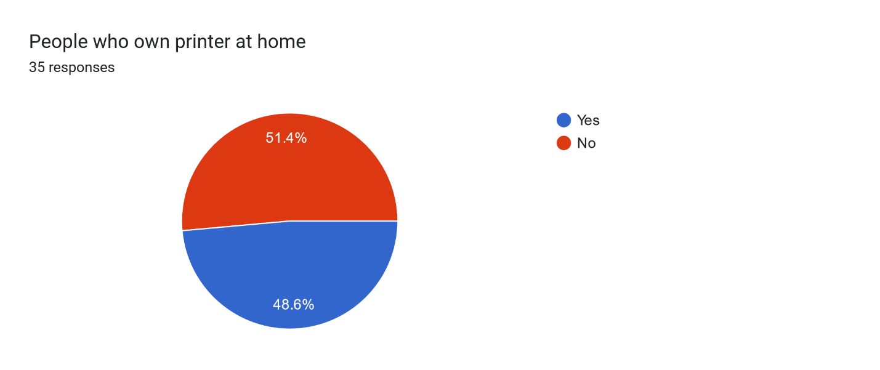

Figure (2)

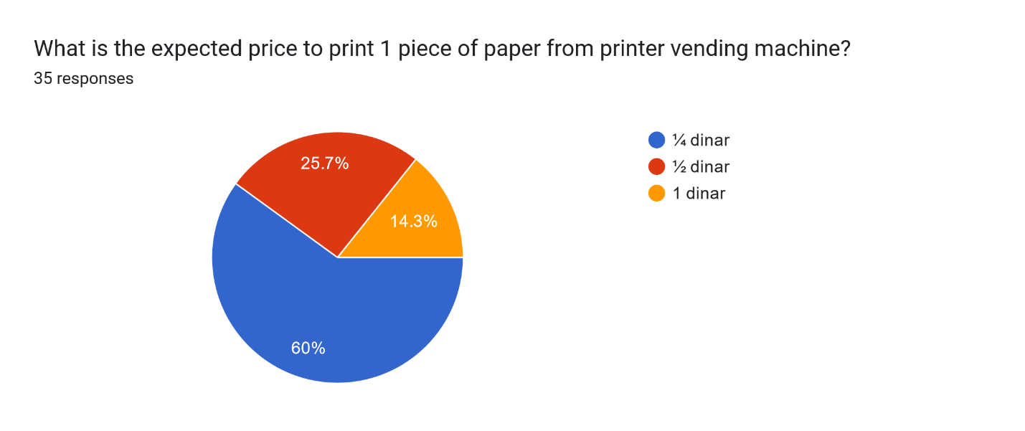

Figure (3)

Figure (4)

Forms response chart. Question title: Would you prefer to use your device or vending machine to print paper?
. Number of responses: 35 responses.

Figure (5)

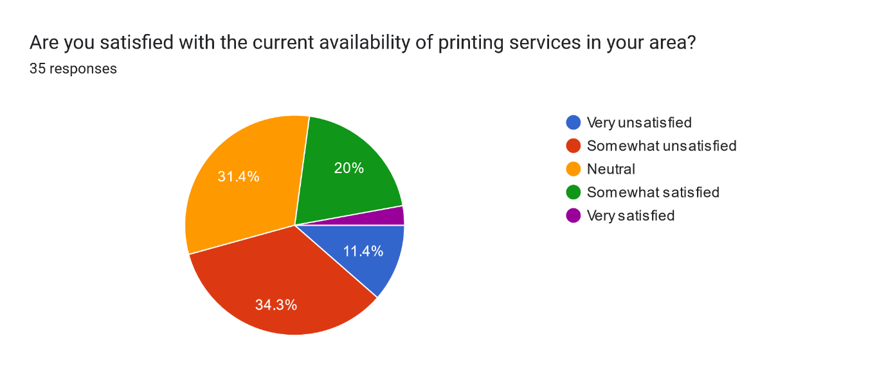

Figure (6)

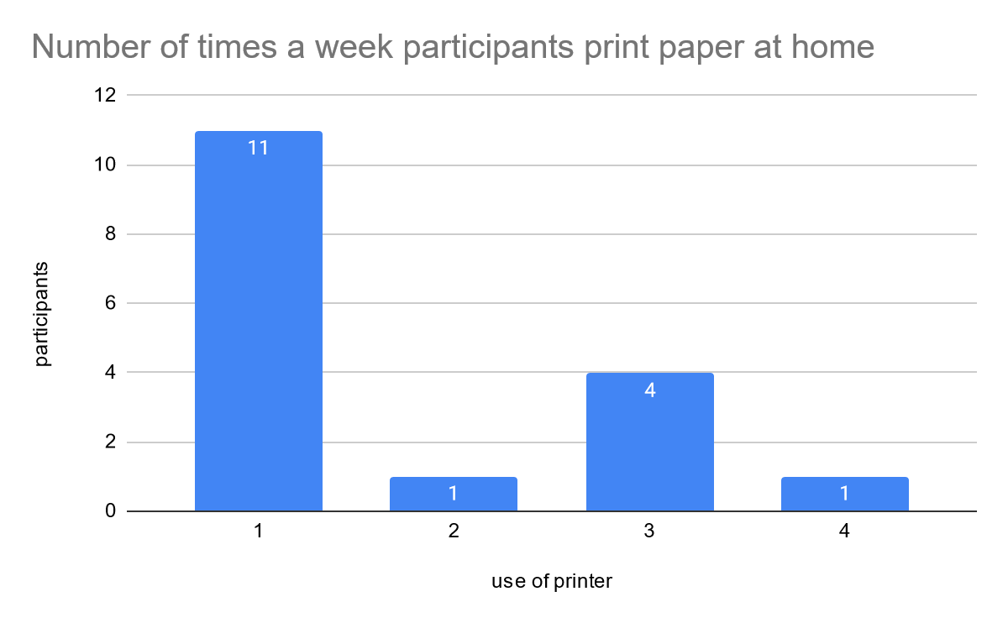

Figure (7)

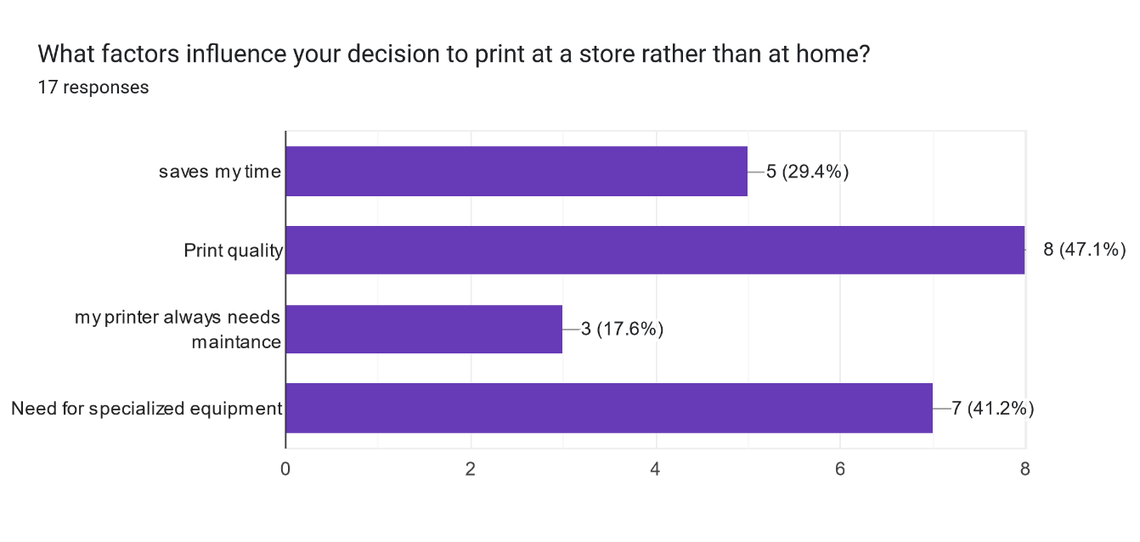

Figure (8)

Based on these results it gave an idea of the environment and market that the software will work on as data shows more than 75% of customers prefer using their personal devices when interacting with software, moreover more than 50% of customers don’t own printer which indicates the software will be useful for them and the other 50% says that sometimes they prefer to go to print store because of the print quality and their machine might need specialized equipment’s.

**Studying Existing System:** This allows for validating the requirement, Existing system serve as a reference point to validate the elicited requirement. By comparing the functionality and features of the existing system with the proposed one, and after research i have chosen 2 vending printer softwires that are the closest to this project which are:-

* Xerox Kiosk

The Kiosk Printer provides print, copy, scan, and fax technology where Customers simply scan a QR code on the printer to transform their mobile device into a remote multifunction printer. An intuitive, touchless experience. With fast, secure checkout via credit/debit cards, prepaid cards and even Apple Pay or Google Pay

* zebra instantThe photo printing machine, designed primarily for entertainment purposes, is exceptionally convenient for malls, movie theaters, parks, and museums. It simply transforms mobile photos into high-quality prints with ease, requiring only an SMS message to the machine. Additionally, The system offers US-based technical support.

Table (1)-Products Comparison

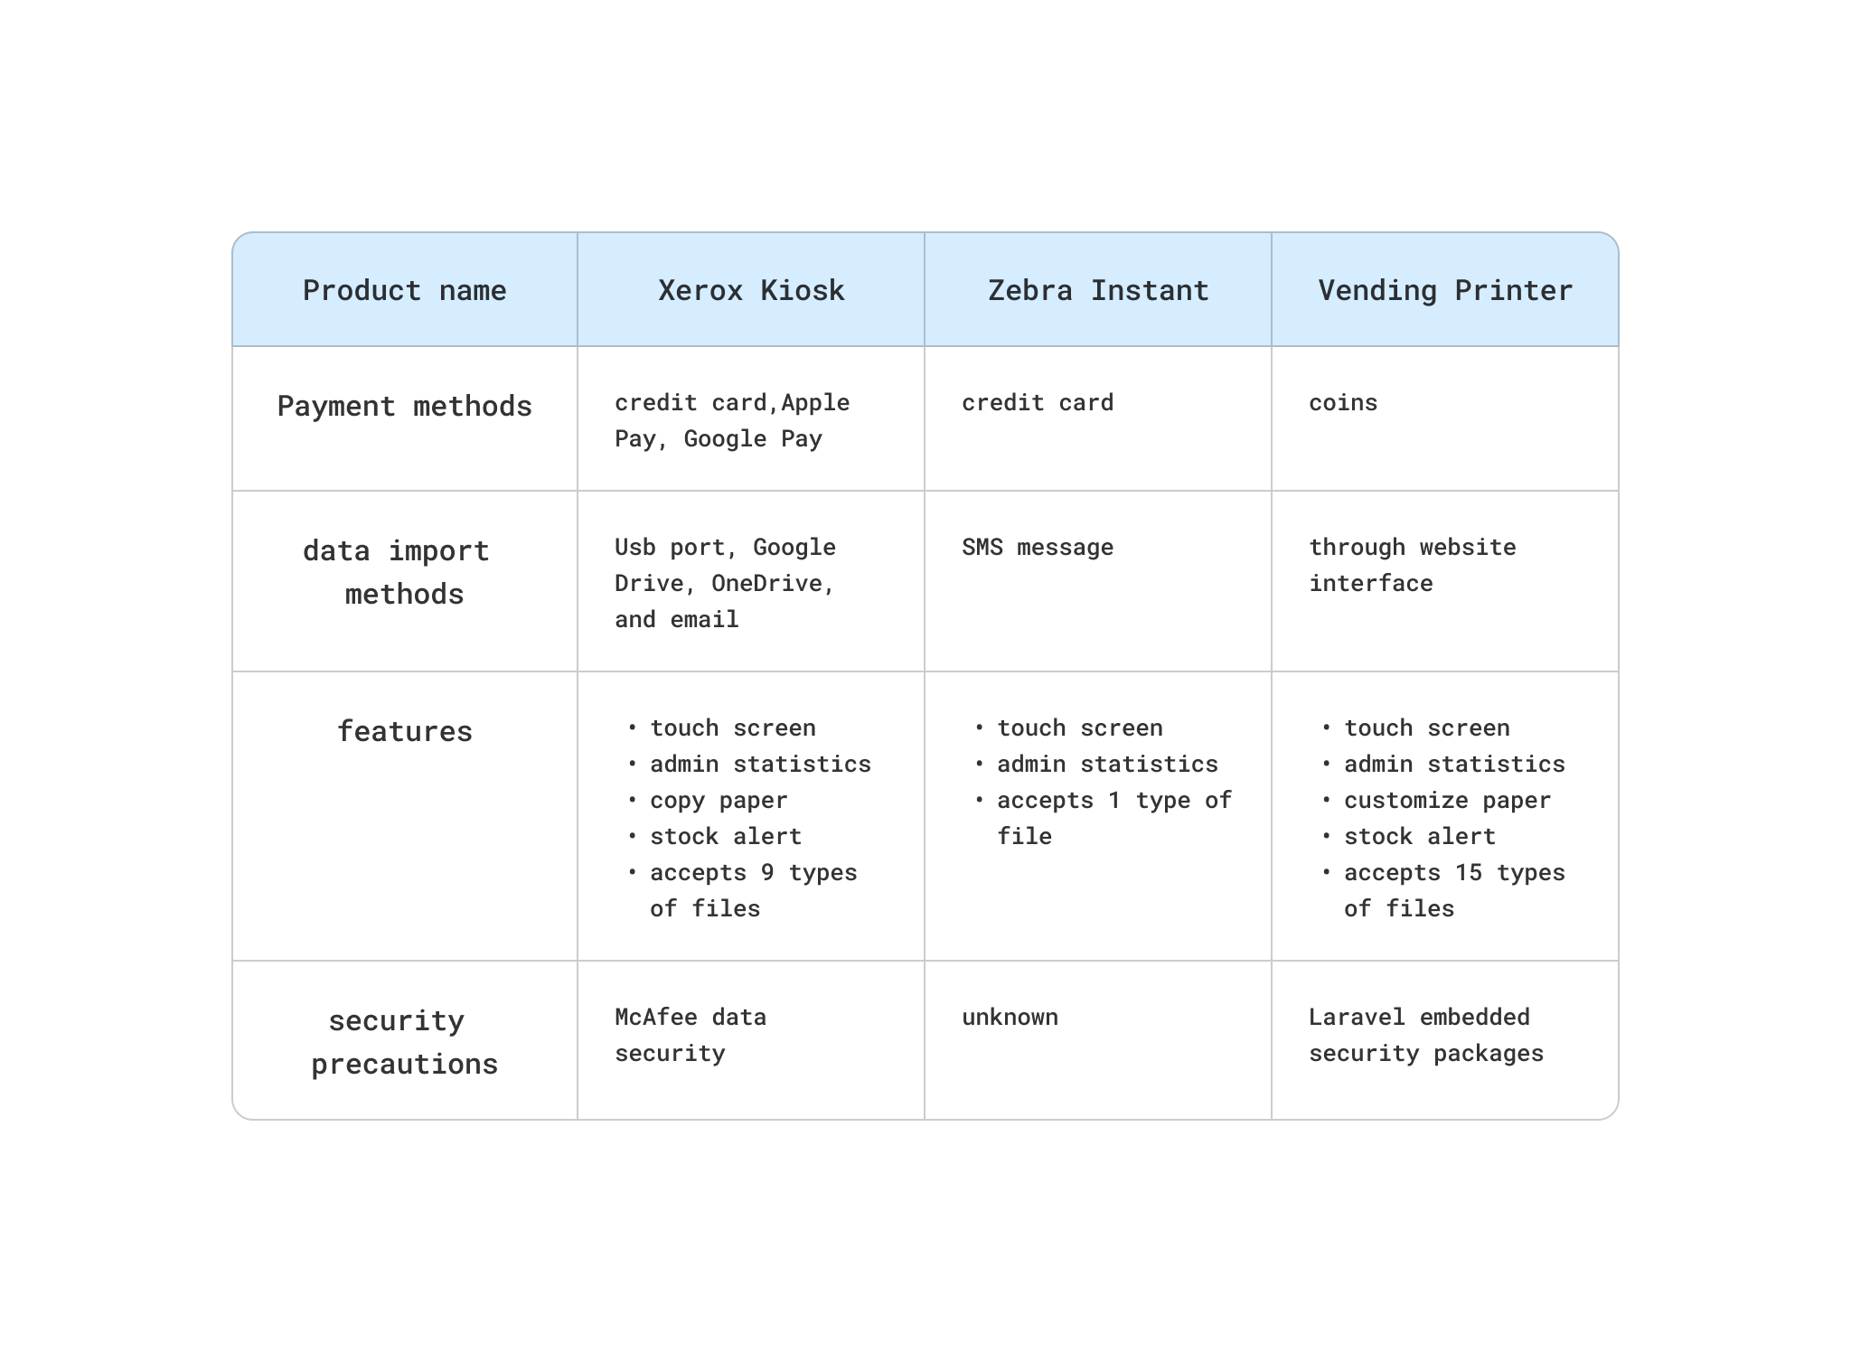

#### 1.3 System scenario

This section represents User perspective and demonstrates how can different users interact with the system.

* The perspective of the customer:

customer will type website link or scan QR code that is on vending machine screen after that they will be able to upload files and customer will have to do reCAPTCHA before submitting files afterwards the customer will be able to choose settings for the files such as number of copies/ color mode, after that accepts terms and condition checkbox, and then once customer clicks submit a text will appear with total price and order number, furthermore the customer can type the order number in the machine and then will insert all the coins after that wait for the papers to print out and collect them.

* The perspective of the admin:

Admin will be able to login from admins portal by entering username and password once admin logs in he/she will access “admins dashboard” where he/she can view status of vending machines for example if it needs to be refilled or if its malfunctioning also in dashboard admin can view statistics like number of orders, profits etc and can view orders and when admin clicks on orders button he/she will view orders table where they can manage orders and search for order number .

* The perspective of the super admin:

Super admin have full control on the backend of the system and his role is to manage admin’s by accessing admin table in the database and managing it.

#### 1.4 Use Case Diagram

Figure (9)

Table (2)-Use cases

|  |  |
| --- | --- |
| Use Case ID | Use Case Name |
| UC1 | Login |
| UC2 | View Machine Statistics |
| UC3 | View Machine Status |
| UC4 | Manage Orders |
| UC5 | Upload Document |
| UC6 | Verify User |
| UC7 | Customize Paper |
| UC8 | Generate code |
| UC9 | Print Paper |
| UC10 | Manage Admin |

#### 1.5 Use Case Tables

|  |  |
| --- | --- |
| Use case name | Login |
| Use case ID | UC1 |
| Actor | Admin |
| Description | actor logging into the system |
| Pre-Conditions | 1-The actor must have an internet connection.  2- The actor must have Opened the login link. |
| Main Scenario (Flow of event) | Actor login with the username and password |
| Alternative scenario | The actor forgets the password and must contact super admin to retrieve the account |
| Exceptional scenario | E1: The actor fills in an invalid email. |
| Post Conditions | The actor dashboard is displayed |
| Priority (1 the highest) | 1/3 |

|  |  |
| --- | --- |
| Use case name | View machine statistics |
| Use case ID | UC2 |
| Actor | Admin |
| Description | Shows graphs and records based on data collected from system and users |
| Pre-Conditions | 1-The actor must be logged in. |
| Main Scenario (Flow of event) | The statistics will be displayed in actor dashboard automatically without any actor’s action |
| Alternative scenario | Not applicable |
| Exceptional scenario | Not applicable |
| Post Conditions | Actor can view statistics |
| Priority (1 the highest) | 3/3 |

|  |  |
| --- | --- |
| Use case name | view machine status |
| Use case ID | UC3 |
| Actor | Admin |
| Description | Shows state and condition of the vending machine and inform actor if the machine is jammed for example if the machine needs paper, ink, or lost connection, if coin jar is full. |
| Pre-Conditions | 1-The actor must be logged in. |
| Main Scenario (Flow of event) | The status will be displayed in actor dashboard automatically without any actors action |
| Alternative scenario | Not applicable |
| Exceptional scenario | Not applicable |
| Post- Conditions | Actor can view status |
| Priority (1 the highest) | 2/3 |

|  |  |
| --- | --- |
| Use case name | Manage Orders |
| Use case ID | UC4 |
| Actor | Admin |
| Description | Edit delete orders table where actor can manage following fields(number of papers, Color Mode, price, status, order code, files) and can search for specific Order number |
| Pre-Conditions | 1-The actor must be logged in. |
| Main Scenario (Flow of event) | Actor clicks on “see all orders” button in actors main dashboard where it will view orders table and actor has option to modify orders by clicking delete button on any order or clicking edit button which will open editing form additionally actor can search for order by clicking on search bar and typing the Order Number. |
| Alternative scenario | Not applicable |
| Exceptional scenario | E1: Actor enters negative number in price and number of paper fields  E2: Actor adds empty order |
| Post-Conditions | Actor successfully managed orders |
| Priority (1 the highest) | 1/3 |

|  |  |
| --- | --- |
| Use case name | Upload Document |
| Use case ID | UC5 |
| Actor | Customer |
| Description | Actor will be able to upload certain types of documents which are (PDF, EPS, JPG, TIFF, PNG, JPEG, SVG, PAGES, DOC, DOCX, PPT, PPTX, XLS, XLSX, TXT) and actor can upload up to 10 files. |
| Pre-Conditions | 1-Equiped with printable file. |
| Main Scenario (Flow of event) | 1-Actor clicks on upload button which will open files explorer depending on the device that the actor is using (windows, mac, phone).  2- actor will choose 1 or more files and clicks “Open”. |
| Alternative scenario | A1- drags and drops the file into the upload document box.  A2- clicks on URL button.  A2- pastes URL image.  A2- clicks confirm. |
| Exceptional scenario | E1: Actor enters not supported file type.  E2: Actor uploads corrupted file.  E3: Actor Exceeds the limit of uploaded files.  E4: Actor inputs URL that isn’t an image |
| Post-Conditions | Actor’s documents are uploaded to the server |
| Priority (1 the highest) | 1/3 |

|  |  |
| --- | --- |
| Use case name | Verify User |
| Use case ID | UC6 |
| Actor | Customer |
| Description | This use case is a security measure to prevent malicious actors from causing harm to the system, the actor will click on checkbox which will open interface that contains riddle or question that only human can solve |
| Pre-Conditions | Not applicable |
| Main Scenario (Flow of event) | Actor Clicks on “I am not robot” checkbox where it will display verification interface that contains riddle or question. |
| Alternative scenario | Not applicable |
| Exceptional scenario | E1: Actor fails to answer question or solve the riddle. |
| Post-Conditions | Actor successfully verifies that he/she is not robot |
| Priority (1 the highest) | 1/3 |

|  |  |
| --- | --- |
| Use case name | Customize Print |
| Use case ID | UC6 |
| Actor | Customer |
| Description | Actor will be able to choose settings for each file like number of copies, color mode(colored or black and white), and delete files |
| Pre-Conditions | 1-Uploaded a file. |
| Main Scenario (Flow of event) | Actor will hover on box of the file than choose number of copies and color mode of that file and is able to delete the file. |
| Alternative scenario | Not Applicable |
| Exceptional scenario | Not Applicable |
| Post- Conditions | Actors updated the settings of the files |
| Priority (1 the highest) | 2/3 |

|  |  |
| --- | --- |
| Use case name | Generate Code |
| Use case ID | UC7 |
| Actor | Customer |
| Description | Actor Clicks save and then actor will receive order  number |
| Pre-Conditions | 1- Uploaded a file. |
| Main Scenario (Flow of event) | 1- Actor clicks on “save”  2- Actor copies “Order Number” |
| Alternative scenario | Not applicable |
| Exceptional scenario | E1:The initial number of copies of all files is 0 therefore if actor didn’t increase number of copies of any file an error message will appear requiring actor to add at least 1 copy |
| Post-Conditions | Actors receives the order number |
| Priority (1 the highest) | 1/3 |

|  |  |
| --- | --- |
| Use case name | Print Paper |
| Use case ID | UC8 |
| Actor | Customer |
| Description | Actor enters order number into the machine after that inserts the coins and then receives the printed papers. |
| Pre-Conditions | 1- Has order code  3- is using the vending machine |
| Main Scenario (Flow of event) | 1- Actor types the order code.  2- inserts number of coins required  3-receives papers |
| Alternative scenario | Not applicable |
| Exceptional scenario | E1: Actor enters invalid code which an error code will appear to inform the actor |
| Post-Conditions | Actors receives printed papers |
| Priority (1 the highest) | 1/3 |

|  |  |
| --- | --- |
| Use case name | Manage Admin |
| Use case ID | UC9 |
| Actor | Super Admin |
| Description | Actor is able to add, edit and delete admin accounts. |
| Pre-Conditions | 1- Has access to the Backend server |
| Main Scenario (Flow of event) | 1- Actor opens admin table in database of the system  2- Actor Manage Admin’s |
| Alternative scenario | Not applicable |
| Exceptional scenario | E1: Actor enters invalid code which an error code will appear to inform the actor |
| Post-Conditions | Actors receives printed papers |
| Priority (1 the highest) | 3/3 |

* 1. **Introduction**
     1. **Purpose**

Students in colleges find difficulty in accessing printers nearby where they must go to a printing center to request a print and there is a chance that the center is closed while a printer machine can simulate the same process/service; By using current technologies and allowing customers to self-serve that way the machine can easily be 24/7 on service and available to anyone with internet access.

* 1. **Overall Description**

**2.2.1 Product Perspective**

The software is a new, self-contained product that will be built from scratch. It is not a follow-on member of a software family. This means that the development of this software will start from the ground up, without any existing software or systems to build upon, additionally part of the software will run on a vending machine with the Windows operating system. It will consist of an application installed on the machine, which will communicate with a backend server.

**2.2.2 Product Functions**

The product has couple major functions which are split in 2 admin, customer functions

customer:

-upload document

-print paper

admin:

-Manage orders

-view statistics and status of the system

Admin super:

-manage admin table

The below figure simplifies the process and demonstrates a high-level illustration of the main function of the system

Figure (10)

**2.2.3 Development process model:**

The ideal software development process is waterfall Model for this project as it is suitable when project requirements are well-defined and stable.

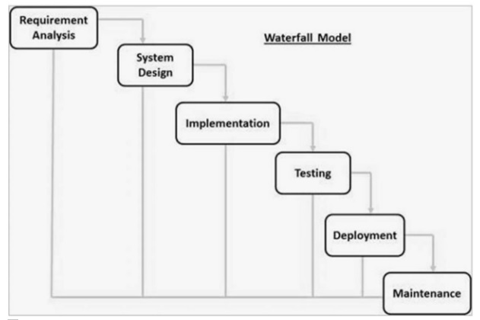

Figure (11)

* + 1. **User Classes and Characteristics**

1. Admin:

Description: Administrators are users with the highest privileges who manage and maintain the machine.

Characteristics:

* Technical expertise: Admins are expected to have a high level of technical knowledge and familiarity with the system.
* Security and privilege: They have access to advanced features and Indicators and have medium privileges.
* Educational level and experience: Admins are required to have specialized training or experience in managing similar systems.

1. Customer:

Description: Customers are users who interact with the system to access the offered services.

Characteristics:

* + - Technical expertise: Customers are not required to have a high level of expertise.
    - Security and privilege levels: Customers have access to certain relevant features only and their privilege is low.
    - Educational level and experience: Customers may not require specialized training and can be assumed to have basic computer literacy.

1. Super Admin:

Description: super admins are actors that have full control on the system and their main role is to manage admin’s table

Characteristics:

* Technical expertise: high level of expertise is required in the information technology field.
* Security and privilege levels: Have full control on the system and super admins privilege is high.
* Educational level and experience: require specialized training and experience in running databases.

**2.2.5 Assumptions and Dependencies**

* It is assumed that the customer users will have basic computer literacy and do not require specialized training.
* Users have access to reliable Internet service.
* The project assumes that the software will require internet access for communication.
  1. **External Interface Requirements**

**2.3.1User Interfaces**

1-Customer Interface

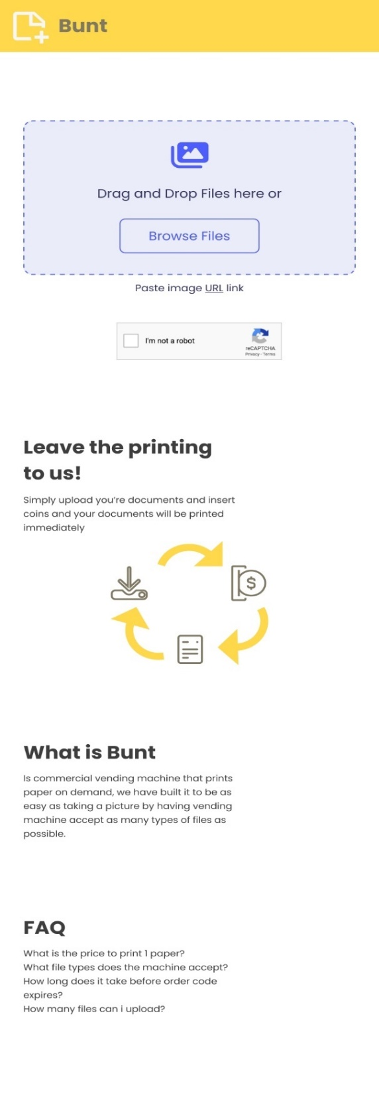

*Figure(13)- UI (2)*

*Figure(12)- UI (1)*

UI(3) Figure(15)- UI(4)*

2-Admin Interface

*Figure(16)- UI(5)*

*Figure(17)- UI(6)*

*Figure(18)- UI(7)*

*Figure(19)- UI(8)*

*3-Vending Machine Interface*

*Figure(20)- UI(9)*

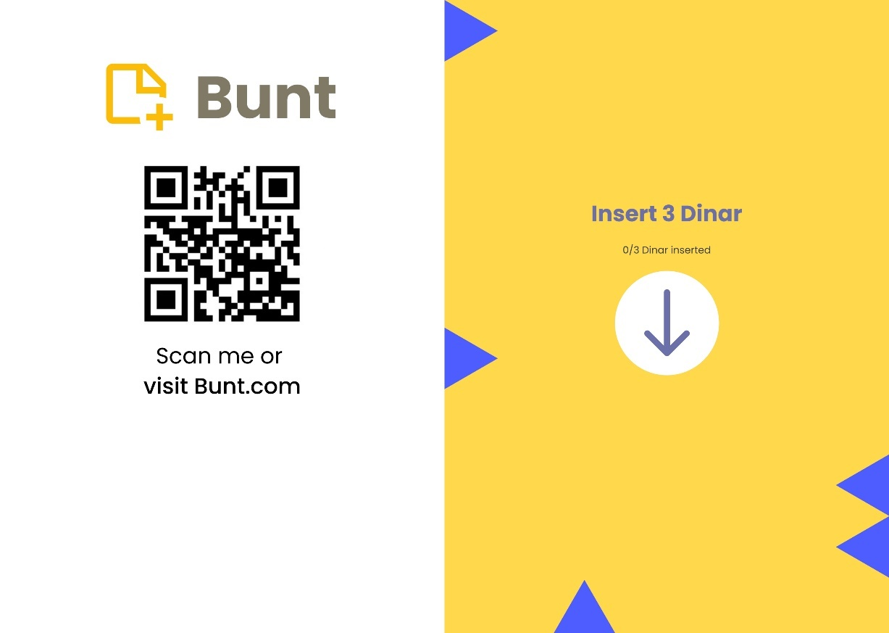

*Figure(21)- UI(10)*

*Figure(22)- UI(11)*

*Figure(23)- UI(12)*

**2.3.2 Hardware Interfaces**The vending printer machine have printer to print customer papers and coin counter to count the coins and must have internet access to communicate to the server side.

*Figure(24)*

**2.3.3 Communications Interfaces**

Several protocols will be used to implement this application which are the following:

* Hypertext Transfer Protocol (HTTP): to communication between web browsers (clients) and web servers. used for retrieving and exchanging data, such as HTML pages, images, and other resources.
* SSH, which stands for Secure Shell, is a network protocol that provides a secure and encrypted method for establishing a remote login or secure shell session between a client and a server. It is commonly used to securely access and manage remote systems over an unsecured network, such as the internet.
* PGP (Pretty Good Privacy) is an encryption program that provides cryptographic privacy and authentication for data communication. It is primarily used for securing email messages and file transfers. PGP uses a combination of symmetric and asymmetric encryption algorithms to ensure the confidentiality and integrity of data.
* FTP (File Transfer Protocol) is a standard network protocol used for transferring files between a client and a server on a computer network. It provides a simple and straightforward method for uploading and downloading files.

**2.4 Functional Requirements**

Table (3) includes the requirements that specify all the functional actions of the application.

|  |  |  |
| --- | --- | --- |
| Requirement ID | UC ID | Requirement |
| FR1 | UC1 | Website shall display (username, password) textbox |
| FR2 | UC1 | Website shall allow actor to view password by clicking on “view password” button |
| FR3 | UC1 | When the actor clicks on login button the website shall display an error message if any of the fields are empty. |
| FR4 | UC1 | When the actor clicks on login button the website shall display an error message if any of the fields have invalid input. |
| FR5 | UC1 | When the actor clicks on login button the website shall display the admin dashboard interface. |
| FR6 | UC2 | Website shall display 4 statistics boxes (Today’s Sale, Total Sales, Total Orders, Profit) |
| FR7 | UC2 | Website shall allow actor to control time period of (Total Sales, Total Orders, Profit) by clicking on the icon besides time period |
| FR8 | UC2 | Actor can choose between (Last 7 Days, Last 30 Days, Last Year) |
| FR9 | UC3 | Website shall display 3 bars (papers, ink, coin jar) and number indicator of each bar and status of the machine (Active, Lost Connection, Resource Alert) |
| FR10 | UC4 | Website shall display an orders table to the actor, showing the relevant fields: number of papers, Color Mode, price, status, order code, and files. |
| FR11 | UC4 | Website shall allow actor to click on “edit” button |
| FR12 | UC4 | Website shall display editing interface where actor can edit (Code, Paper, Price) text boxes and (Status, File) select boxes |
| FR13 | UC4 | Website shall allow actor to click “Submit” button |
| FR14 | UC5 | Website should allow actor to click on “Browse Files” to upload files which will open file explorer window |
| FR15 | UC5 | Website should allow actor to upload files by dragging and dropping files inside “Upload Box” |
| FR16 | UC5 | Website should allow actor to click on “URL” text |
| FR17 | UC5 | Website shall display Text box and “submit” button where actor can paste image URL link. |
| FR18 | UC5 | When the actor clicks on submit button the website shall display an error message if the URL link is not an image. |
| FR19 | UC5 | When the actor upload files the website shall display an error message if the uploaded document isn’t one of these files (PDF, EPS, JPG, TIFF, PNG, JPEG, SVG, PAGES, DOC, DOCX, PPT, PPTX, XLS, XLSX, TXT) |
| FR20 | UC5 | When the actor upload files the website shall display an error message if the actor uploaded more than 10 files |
| FR21 | UC5 | When the actor upload files the website shall display an error message if the uploaded file is corrupted |
| FR22 | UC5 | When the actor upload files, the website shall display customize paper interface if the customer passed verification test |
| FR23 | UC6 | Website should allow actor to click on “I am not robot” to verify the actor is not a robot |
| FR24 | UC6 | When the actor passes verification test the website shall display customize paper interface if the customer uploaded document |
| FR25 | UC7 | The website shall display the Customize Paper interface |
| FR26 | UC7 | The website shall allow actor to choose (Color Mode, number of copies) select boxes |
| FR27 | UC7 | The website shall update total price once any change happens in the settings of any file |
| FR28 | UC7 | When the actor clicks on “Save” button the website shall display an error message if all the files have 0 copies. |
| FR29 | UC8 | The website shall allow actor to click on “I agree to the terms and conditions” check box |
| FR30 | UC8 | when the actor clicks on “Save” button the website shall display error message if the actor didn’t click on the check box |
| FR31 | UC8 | when the actor clicks on “Save” button the website shall display Order Code interface that contains (Order code, Total Price, Number of Papers) texts |
| FR32 | UC9 | The application shall allow actor to type the order number |
| FR33 | UC9 | when the actor types all required numbers, the application shall display error message if the order number doesn’t exist |
| FR34 | UC9 | when the actor types all required numbers, the application shall display “insert coins” interface |
| FR35 | UC9 | The application shall allow actor to insert required coins in the coins slot |
| FR36 | UC9 | The application should display “downloading files” interface when the actor has inserted all the required coins |
| FR37 | UC9 | The application should display “printing files” interface once all the files have been downloaded |
| FR38 | UC10 | The server shall allow actor to manage admin table(Username, Password) |

**2.5 Nonfunctional Requirements**

**2.5.1 Performance Requirements**

-The vending machine application should start downloading files once the customer entered the order number successfully and that’s because the internet connection might be slow hence starting the download process early is essential

**2.5.2 Security Requirements**

-Laravel supplies security components that handle file transferring process and makes sure that the files haven’t been tampered with during the transfer process

-Laravel supplies security middleware to handle passwords encryption and request forgery

-In Main interface of the website the server shouldn’t upload the files until the customer has successfully done the reCAPTCHA to verify that the customer isn’t a robot

-In main interface of the website the server shouldn’t allow actor to upload more than 10 files to limit the malicious actors to cause harm to the server.

-The admin login page should display “wrong email or password” message when the actor enters either wrong password or non-existing username to prevent the actor from knowing what are the valid usernames

-The admin login page should have the password text hidden and allow actor to view it by clicking on the “eye” button to prevent malicious actors to shoulder surf

**2.5.3 Software Quality Attributes**

1. Portability: the system is built in a way such that the customer can upload documents through the website without the need to be currently using the machine
2. Adaptability: the website will accept all types of files even the ones that are not accepted by the printer and will change them to type of file that can be printed.
3. Flexibility:

* customers have multiple methods to upload file either by dragging and dropping files or clicking “browse files” or pasting URL link of an image.
* Customers can upload more files in “customize paper” interface and can delete files by clicking on trash pin.
* customer can copy order code just by clicking on the order code box in “generate code” interface.
* customer can enter website URL either by scanning the code on the vending machine application or by typing the URL link that is displayed in the Main application interface.

1. Reusability: “Upload Document” use case will be used in “main page” interface and “customize paper” interface if the customer wanted to upload more files
2. Maintainability: admin manage orders

________________________________________________________________________

**2.6 Glossary**

Shoulder surf: In computer security, shoulder surfing is a type of social engineering technique used to obtain information such as personal identification numbers, passwords and other confidential data by looking over the victim's shoulder.

reCAPTCHA: service that helps protect websites from spam and abuse. A “CAPTCHA” is a turing test to tell human and bots apart.